


Contents
Overview 1
Lesson: Implementing the Global Catalog
in Active Directory 2
Lesson: Determining the Placement of
Domain Controllers in Active Directory 13
Lesson: Planning the Placement of
Domain Controllers 20
Lab A: Implementing the Placement of Domain Controllers 30

Module 8: Implementing the Placement of Domain Controllers

Information in this document, including URL and other Internet Web site references, is subject to change without notice. Unless otherwise noted, the example companies, organizations, products, domain names, e-mail addresses, logos, people, places, and events depicted herein are fictitious, and no association with any real company, organization, product, domain name, e-mail address, logo, person, place or event is intended or should be inferred. Complying with all applicable copyright laws is the responsibility of the user. Without limiting the rights under copyright, no part of this document may be reproduced, stored in or introduced into a retrieval system, or transmitted in any form or by any means (electronic, mechanical, photocopying, recording, or otherwise), or for any purpose, without the express written permission of Microsoft Corporation.

Microsoft may have patents, patent applications, trademarks, copyrights, or other intellectual property rights covering subject matter in this document. Except as expressly provided in any written license agreement from Microsoft, the furnishing of this document does not give you any license to these patents, trademarks, copyrights, or other intellectual property.

© 2003 Microsoft Corporation. All rights reserved.

Microsoft, MS-DOS, Windows, Windows NT, Active Directory, Active X, MSDN, PowerPoint, Visio, Visual Basic, Visual C++, and Windows Media are either registered trademarks or trademarks of Microsoft Corporation in the United States and/or other countries.

The names of actual companies and products mentioned herein may be the trademarks of their respective owners.

Overview
INCLUDEPICTURE "E:\\Documents and Settings\\Annie Chowdhry\\Application Data\\Microsoft\\Word\\PowerPnt\\2279B_08\\Slide_420.jpg" \* MERGEFORMATINET INCLUDEPICTURE "../Modules/PowerPnt/2279B_08/Slide_420.jpg" \* MERGEFORMATINET 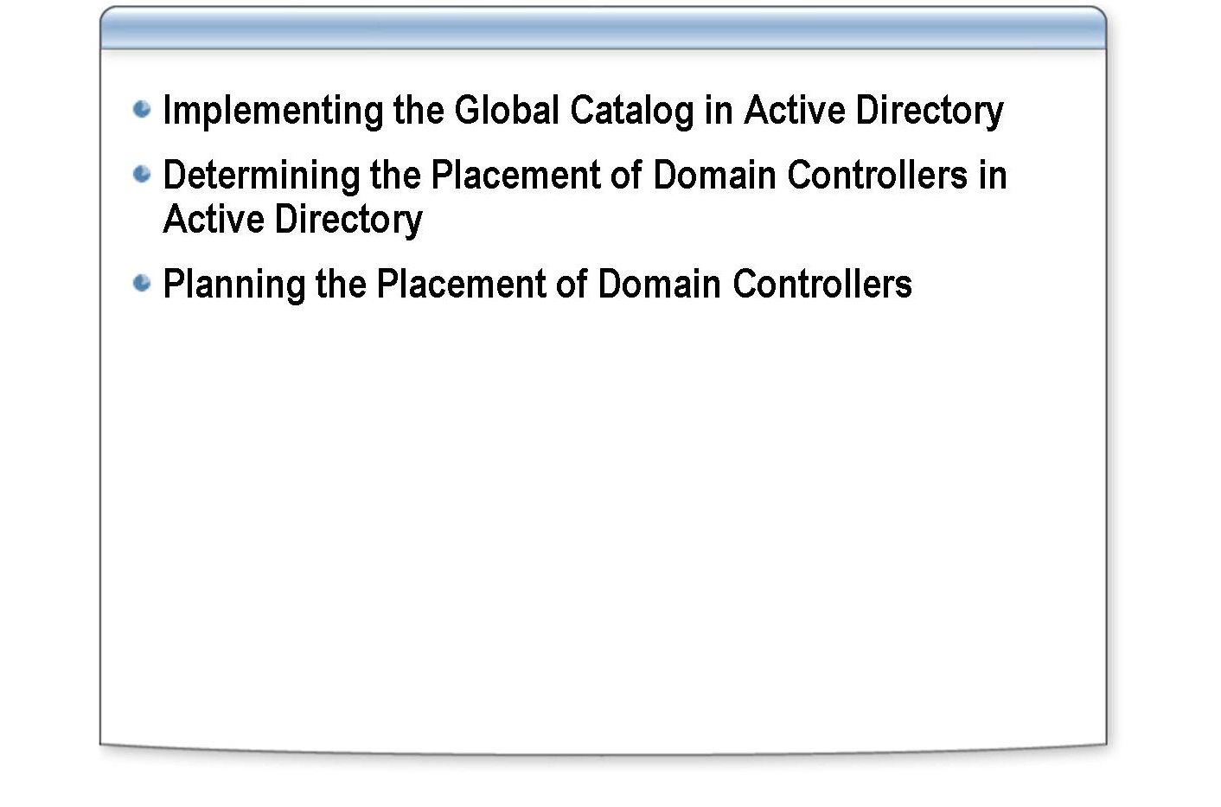
*****************************illegal for non-trainer use******************************
A domain controller is a computer running Microsoft® Windows® Server 2003 that stores a replica of the domain directory. Having more than one domain controller in a domain provides fault tolerance. If one domain controller is offline, another domain controller can provide all of the required functions, such as recording changes to the Active Directory® directory service. Domain controllers manage all aspects of users’ domain interaction, such as locating Active Directory objects and validating user logon attempts.
Introduction
Because a domain may contain one or more domain controllers, and domain controllers perform various key functions, the placement of domain controllers is an important task in the implementation of Active Directory.
After completing this module, you will be able to:
Objectives
- Implement the global catalog in Active Directory.
- Determine the placement of domain controllers in Active Directory.
- Plan for the placement of domain controllers in Active Directory.

Lesson: Implementing the Global Catalog in Active Directory

INCLUDEPICTURE "../Modules/PowerPnt/2279B_08/Slide_473.jpg" \* MERGEFORMATINET 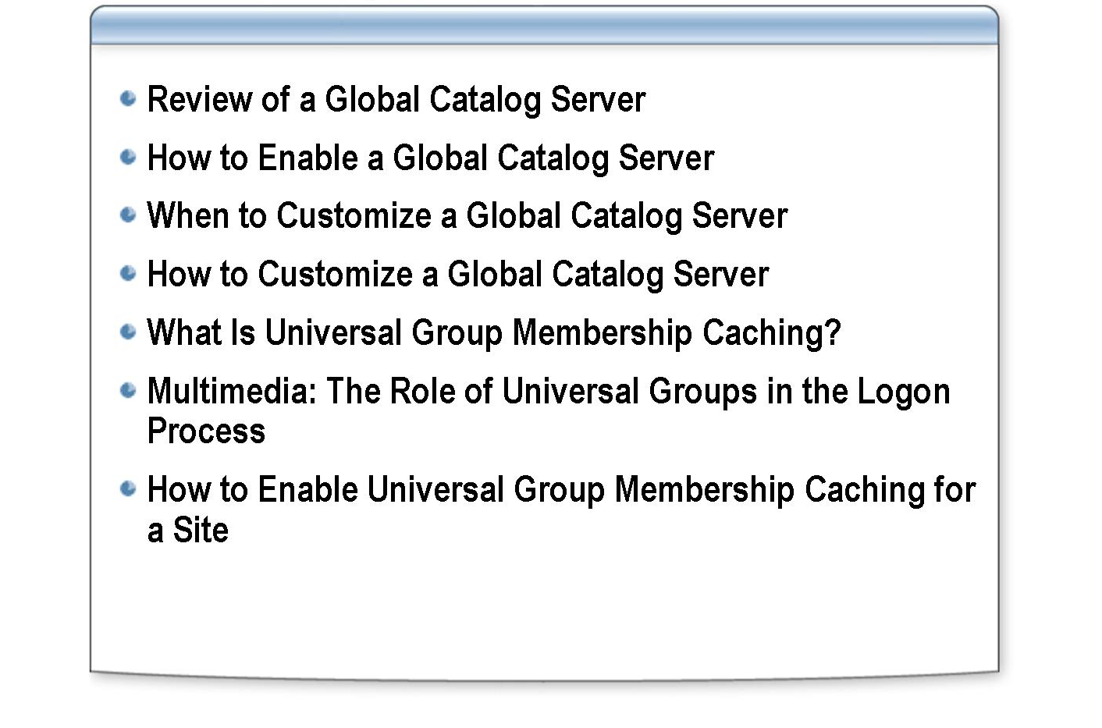
*****************************illegal for non-trainer use******************************
The global catalog is the central repository of information about objects in a forest in Active Directory. Universal group membership caching in Windows Server 2003 reduces traffic and improves logon response across slow wide area network (WAN) links. You must understand global catalog servers and universal group membership caching to plan the placement of domain controllers successfully in your network.
Introduction
After completing this lesson, you will be able to:
Lesson objectives
- Review the purpose of a global catalog server.
- Enable a global catalog server.
- Explain considerations for customizing a global catalog server.
- Customize a global catalog server.
- Explain the purpose of universal group membership caching.
- Explain the role of universal groups in the logon process.
- Enable universal group membership caching for a site.

Review of a Global Catalog Server

INCLUDEPICTURE "E:\\Documents and Settings\\Annie Chowdhry\\Application Data\\Microsoft\\Word\\PowerPnt\\2279B_08\\Slide_509.jpg" \* MERGEFORMATINET INCLUDEPICTURE "../Modules/PowerPnt/2279B_08/Slide_509.jpg" \* MERGEFORMATINET 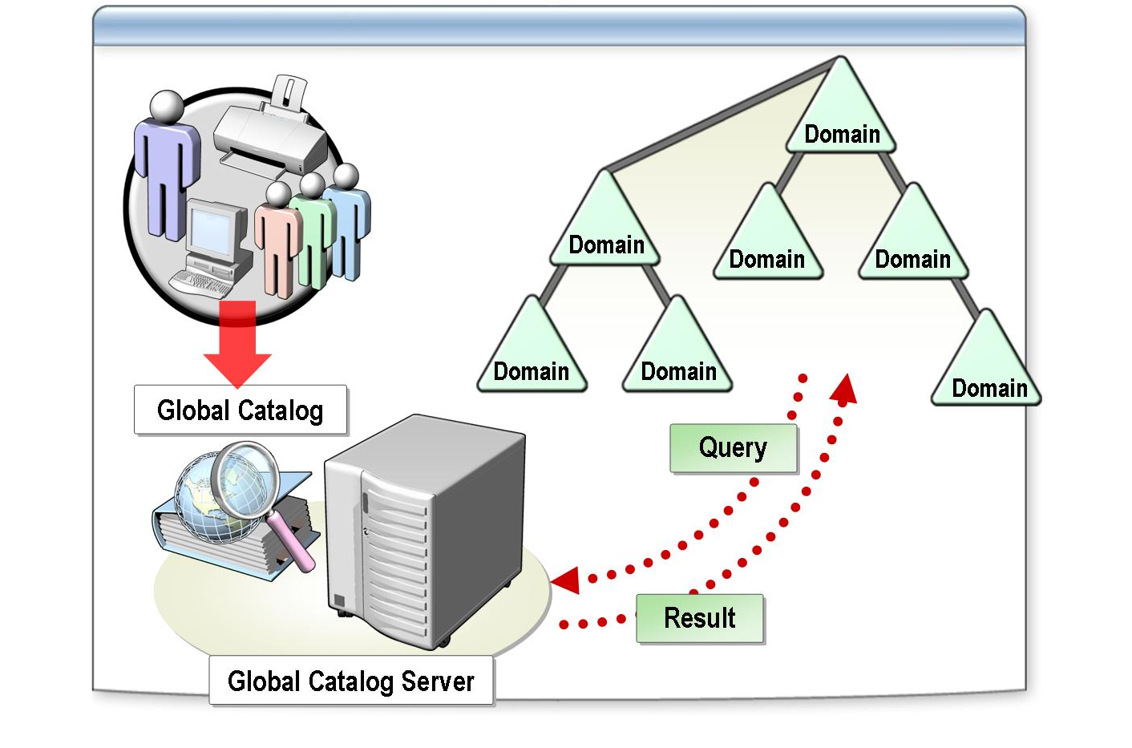
*****************************illegal for non-trainer use******************************
Active Directory automatically creates a global catalog on the first domain controller in the forest and is known as a global catalog server. You can add global catalog functionality to other domain controllers or change the default location of the global catalog to another domain controller.
Introduction
A global catalog server performs the following key functions:
Key functions
- It enables network logon by providing universal group membership information to a domain controller when a logon process is initiated.
- It finds directory information regardless of which domain in the forest actually contains the data.

A global catalog resolves user principal names when the authenticating domain controller does not know the account. For example, if a user account is located in example1.nwtraders.msft and the user decides to log on by using a user principal name of user1@example1.nwtraders.msft from a computer that is located in example2.nwtraders.msft, the domain controller in example2. nwtraders.msft cannot find the user account, and will then contact a global catalog server to complete the logon process.
Global catalog and user principal name authentication
A global catalog supplies information about universal group memberships in a multiple domain environment. Unlike global group memberships, which Active Directory stores in each domain, universal group memberships are stored only in a global catalog. For example, when a user who belongs to a universal group logs on to a domain that is set to Windows 2000 native or Windows Server 2003 domain functional level, the global catalog provides universal group membership information about the user account.
Global catalog and universal group membership
If a global catalog is not available when a user logs on to a domain running in Windows 2000 native or Windows Server 2003 domain functional level, the domain controller that processes the user’s logon request denies the request, and the user cannot log on.

What happens when there is no global catalog?
If no domain controllers are available to process a user’s logon request, the domain controller processes the logon request by using the user’s cached credentials. This feature allows users to log on to portable computers when they are not connected to the corporate network.
The Administrator account in the domain can always log on, even when no global catalog server is available.

Client computers must have access to a global catalog server to log on. Therefore, in most cases, you must have at least one global catalog server in every site to gain the benefits of minimizing network traffic that using sites provides.
Important

For more information about cached credentials, see “Review of a Global Catalog Server” in Module 8 on the Appendices page on the Student Materials compact disc.
Note

How to Enable a Global Catalog Server

INCLUDEPICTURE "E:\\Documents and Settings\\Annie Chowdhry\\Application Data\\Microsoft\\Word\\PowerPnt\\2279B_08\\Slide_512.jpg" \* MERGEFORMATINET INCLUDEPICTURE "../Modules/PowerPnt/2279B_08/Slide_512.jpg" \* MERGEFORMATINET 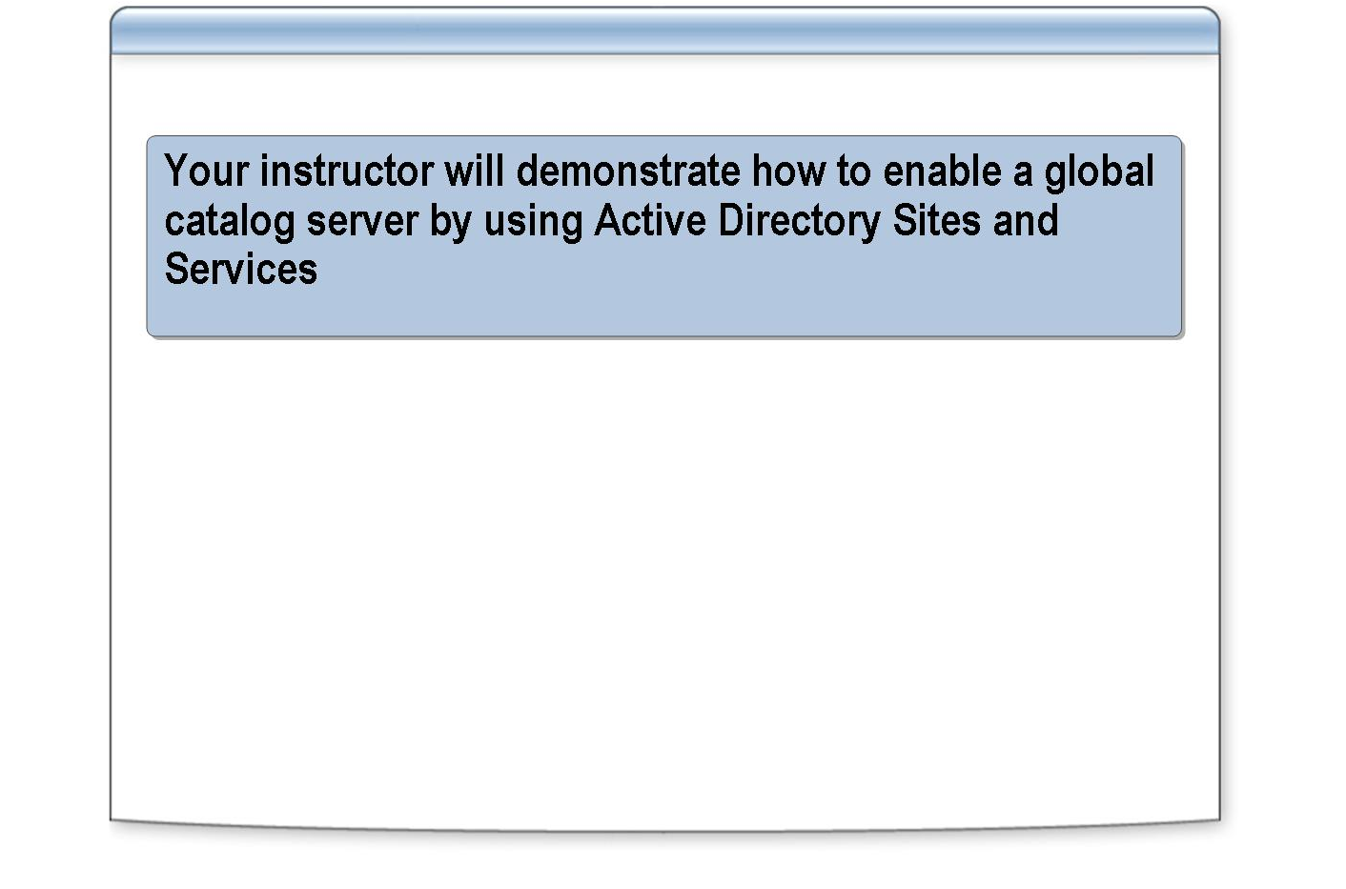
*****************************illegal for non-trainer use******************************
To perform this procedure, you must be a member of the Domain Admins group or the Enterprise Admins group in Active Directory, or you must have been delegated the appropriate permissions.
Introduction
To enable a global catalog server, perform the following steps:
Procedure
    - Open Active Directory Sites and Services.
    - In the console tree, browse to the domain controller that will host the global catalog.
    - In the details pane, right-click NTDS Settings, and then click Properties.
    - Select the Global Catalog check box, and then click OK.

Enabling a global catalog server can cause additional replication traffic while the server gets a complete initial copy of the entire global catalog. The domain controller does not advertise itself as a global catalog server until it has received the global catalog information through replication.
Note

When to Customize a Global Catalog Server

INCLUDEPICTURE "../Modules/PowerPnt/2279B_08/Slide_516.jpg" \* MERGEFORMATINET 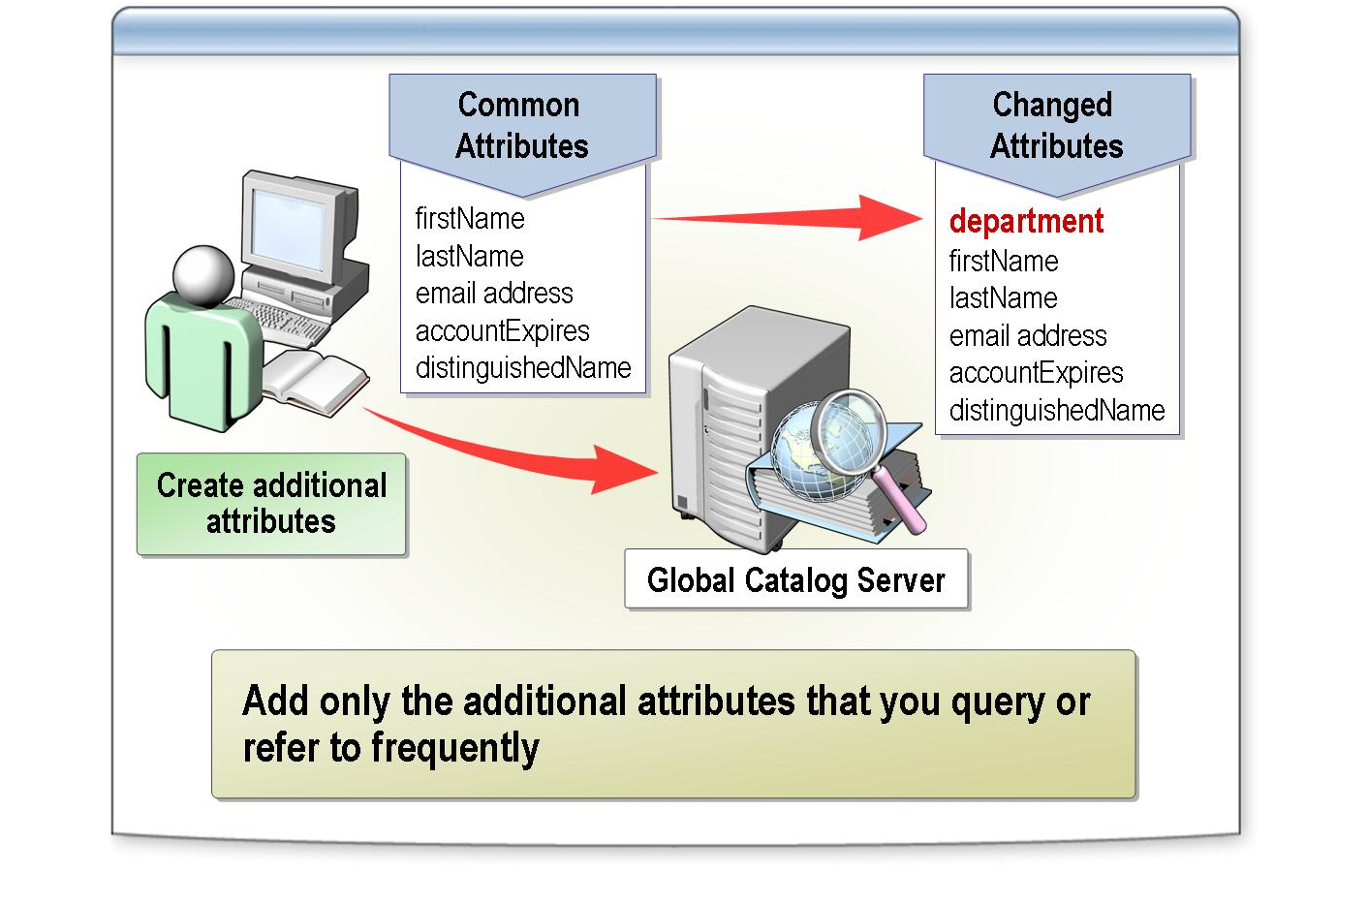
*****************************illegal for non-trainer use******************************
Sometimes you may want to customize the global catalog server to include additional attributes. However, consider your options carefully because changes to attributes can affect network traffic.
Introduction
By default, the global catalog server contains an object’s most common attributes for every object in the entire forest. Applications and users can query these attributes. For example, you can find a user by first name, last name, e-mail address, or other common properties of a user account.
To decide whether to add an attribute to a global catalog server, use these considerations:
Considerations
- Add only attributes that users or applications in your organization frequently query or refer to.
- Determine how frequently an attribute is updated during replication. Active Directory replicates all attributes that are stored in the global catalog to every global catalog server in the forest. The smaller the attribute, the lower the impact on replication. If the attribute is large, but seldom changes, it has a smaller replication impact than a small attribute that changes often.

For more information about attributes in a global catalog server, see “When to Customize the Global Catalog Server” in Module 8 on the Appendices page on the Student Materials compact disc.
Note

How to Customize a Global Catalog Server

INCLUDEPICTURE "E:\\Documents and Settings\\Annie Chowdhry\\Application Data\\Microsoft\\Word\\PowerPnt\\2279B_08\\Slide_513.jpg" \* MERGEFORMATINET INCLUDEPICTURE "../Modules/PowerPnt/2279B_08/Slide_513.jpg" \* MERGEFORMATINET 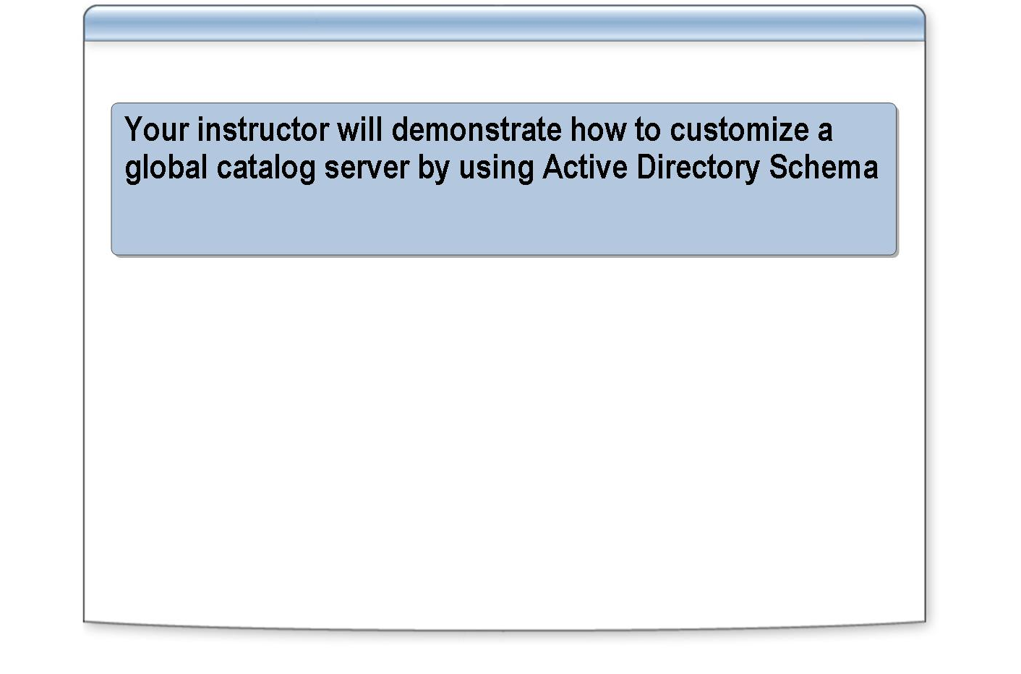
*****************************illegal for non-trainer use******************************
To perform this procedure, you must be a member of the Schema Admins group in Active Directory, or you must have been delegated the appropriate permissions.
Introduction
To add an attribute to a global catalog server, perform the following steps:
Procedure
    - Create a new custom MMC console:
      - Click Start, click Run, type regsvr32 schmmgmt.dll and then click OK.
      - Click Start, click Run, type mmc and then press ENTER.
      - On the File menu, click Add/Remove Snap-in.
      - In the Add/Remove Snap-in dialog box, click Add.
      - In the Add Standalone Snap-in dialog box, double-click Active Directory Schema, and then click Close.
      - In the Add/Remove Snap-in dialog box, click OK.
      - On the File menu, click Save As.
      - In the File name box, type Active Directory Schema and then click Save.
      - Close the custom MMC console.
    - Click Start, click All Programs, click Administrative Tools, and then click Active Directory Schema.msc.
    - In the console tree, expand Active Directory Schema, and then click Attributes.
    - In the details pane, right-click the attribute that you want to add to the global catalog server, and then click Properties.

    - Click Replicate this attribute to the Global Catalog, and then click OK.

If the forest functional level is not set to Windows Server 2003, adding a new attribute to the global catalog server causes a full synchronization of the global catalog server.
Warning

What Is Universal Group Membership Caching?

INCLUDEPICTURE "E:\\Documents and Settings\\Annie Chowdhry\\Application Data\\Microsoft\\Word\\PowerPnt\\2279B_08\\Slide_510.jpg" \* MERGEFORMATINET INCLUDEPICTURE "../Modules/PowerPnt/2279B_08/Slide_510.jpg" \* MERGEFORMATINET 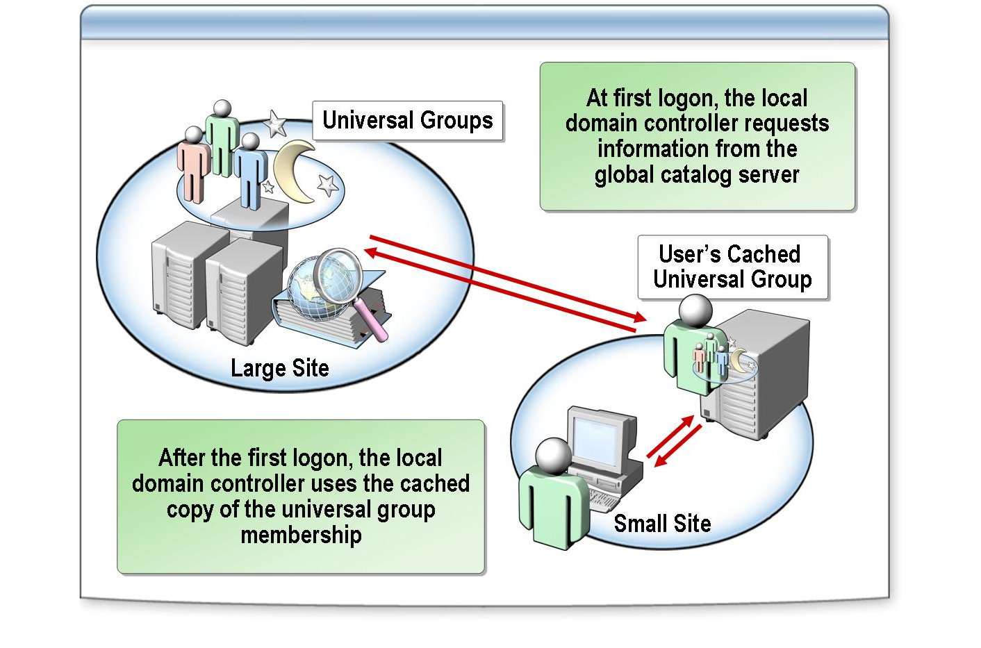
*****************************illegal for non-trainer use******************************
Network bandwidth and server hardware limitations may make it impractical for an organization to have a global catalog server in smaller branch office locations. For these sites, you can deploy domain controllers running Windows Server 2003, and then enable universal group membership caching for the site.
Introduction
A domain controller in a site that has universal group membership caching enabled stores information locally after a user attempts to log on for the first time. The domain controller obtains the universal group membership information for the user from a global catalog server in another site. It then caches the information indefinitely and periodically refreshes it. The next time that the user tries to log on, the domain controller obtains the universal group membership information from its local cache without contacting a global catalog server.
Why use universal group membership caching?
By default, the universal group membership information contained in the cache of each domain controller is refreshed every eight hours. To refresh the cache, domain controllers running Windows Server 2003 send a universal group membership confirmation request to a designated global catalog server. Windows Server 2003 updates up to 500 universal group memberships at once.
Refresh interval for universal group membership caching

Multimedia: The Role of Universal Groups in the Logon Process

INCLUDEPICTURE "E:\\Documents and Settings\\Annie Chowdhry\\Application Data\\Microsoft\\Word\\PowerPnt\\2279B_08\\Slide_511.jpg" \* MERGEFORMATINET INCLUDEPICTURE "../Modules/PowerPnt/2279B_08/Slide_511.jpg" \* MERGEFORMATINET 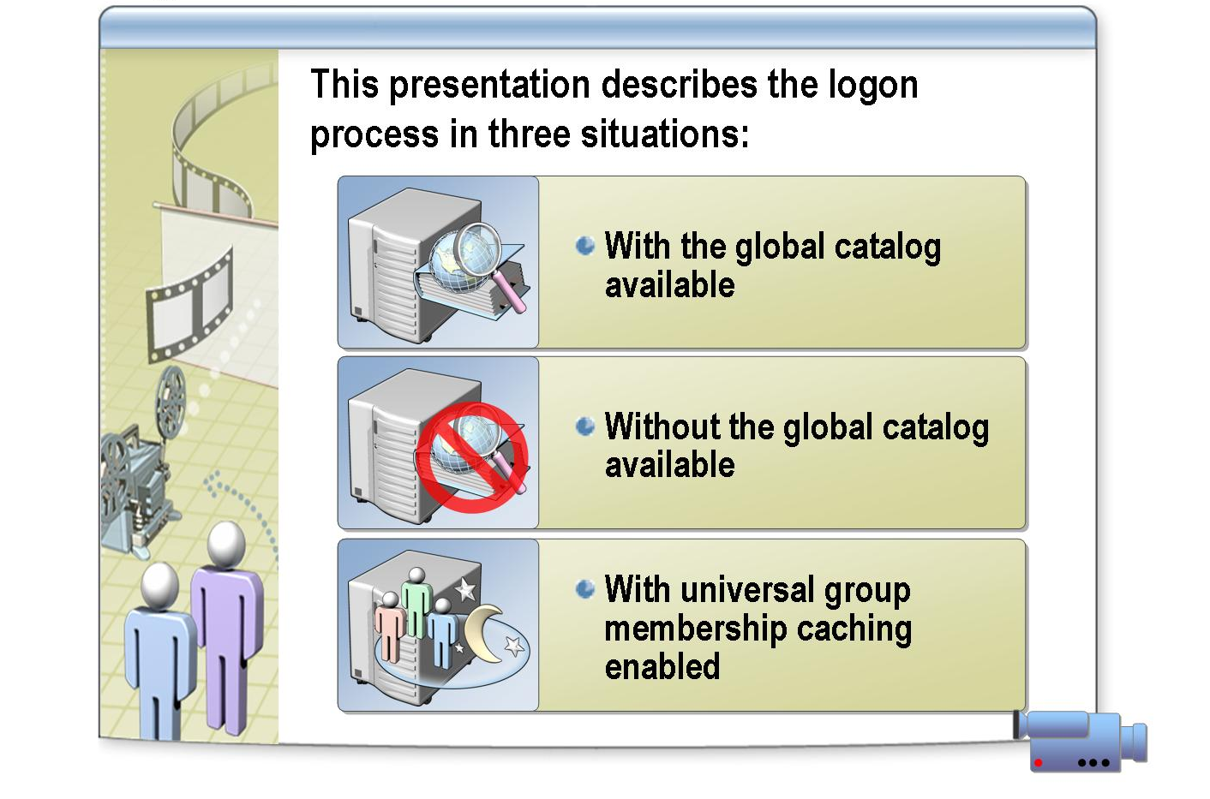
*****************************illegal for non-trainer use******************************
To view The Role of Universal Groups in the Logon Process presentation, open the Web page on the Student Materials compact disc, click Multimedia, and then click the title of the presentation. Do not open this presentation unless the instructor tells you to.
File Location
After viewing this presentation, you will be able to:
Objectives
- Discuss the role of group membership in authentication and authorization.
- Describe how universal group membership is stored in the global catalog.
- Discuss the role of the global catalog server during authentication and authorization.
- Determine when to place a global catalog server at a remote site.
- Determine when to enable universal group membership caching.
- Discuss the role of group membership in authentication and authorization.

The key points of this presentation are:
Key points
- Universal group membership is critical to a successful logon. If the domain controller cannot enumerate the user’s universal group membership, the user is denied an interactive logon. To complete the logon process, the client computer on which the user is performing the interactive logon must have access to either a global catalog server or the cached information.
- When a user logs on, the domain controller that authenticates the user must be able to contact a global catalog server to enumerate the user's universal group memberships. If the domain controller accesses the global catalog server over a WAN, users cannot log on if the WAN link is down.
- If a WAN connection can bear the replication traffic, locate a global catalog server at the site. If replication traffic is a burden to the WAN link, enable universal group membership caching in the site.

How to Enable Universal Group Membership Caching for a Site

INCLUDEPICTURE "E:\\Documents and Settings\\Annie Chowdhry\\Application Data\\Microsoft\\Word\\PowerPnt\\2279B_08\\Slide_514.jpg" \* MERGEFORMATINET INCLUDEPICTURE "../Modules/PowerPnt/2279B_08/Slide_514.jpg" \* MERGEFORMATINET 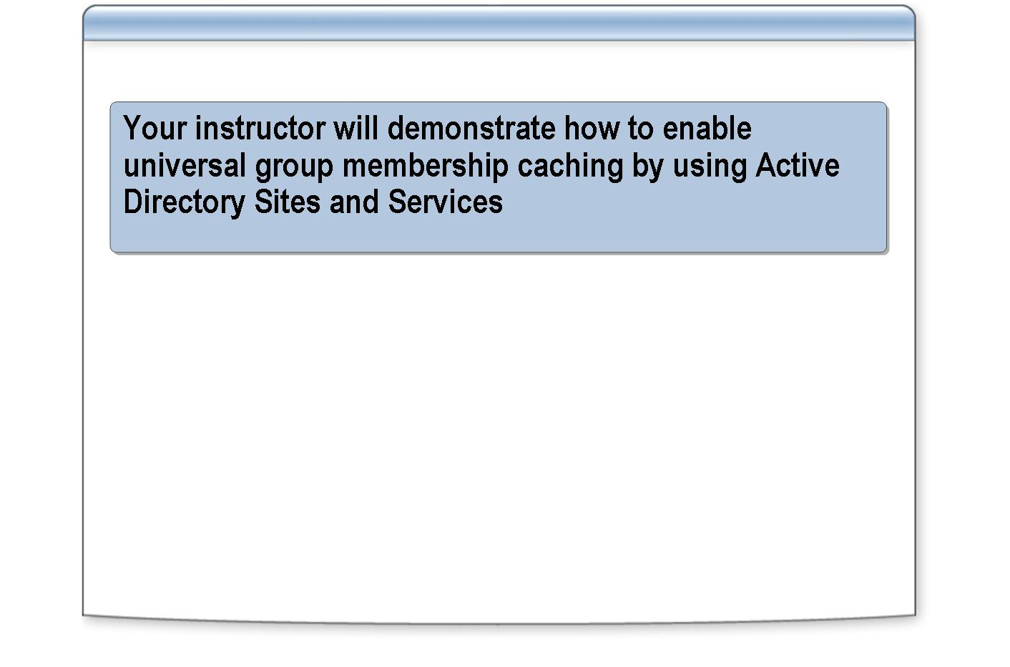
*****************************illegal for non-trainer use******************************
To perform this procedure, you must be a member of the Domain Admins group in the forest root domain or the Enterprise Admins group in Active Directory, or you must have been delegated the appropriate permissions.
Introduction
To enable universal group membership caching for a site that does not have a global catalog server, perform the following steps:
Procedure
    - In Active Directory Sites and Services, in the console tree, expand sites, and then click the site for which you want to enable universal group membership caching.
    - In the details pane, right-click NTDS Site Settings, and then click Properties.
    - Select the Enable Universal Group Membership Caching check box, select a site on which this site refreshes its cache, and then click OK.

By default, a domain controller refreshes the cache on the nearest site that has a global catalog server. You can select another site that has a global catalog server on which to refresh the cache.
Note

Practice: Implementing the Global Catalog in Active Directory

INCLUDEPICTURE "E:\\Documents and Settings\\Annie Chowdhry\\Application Data\\Microsoft\\Word\\PowerPnt\\2279B_08\\Slide_436.jpg" \* MERGEFORMATINET INCLUDEPICTURE "../Modules/PowerPnt/2279B_08/Slide_436.jpg" \* MERGEFORMATINET 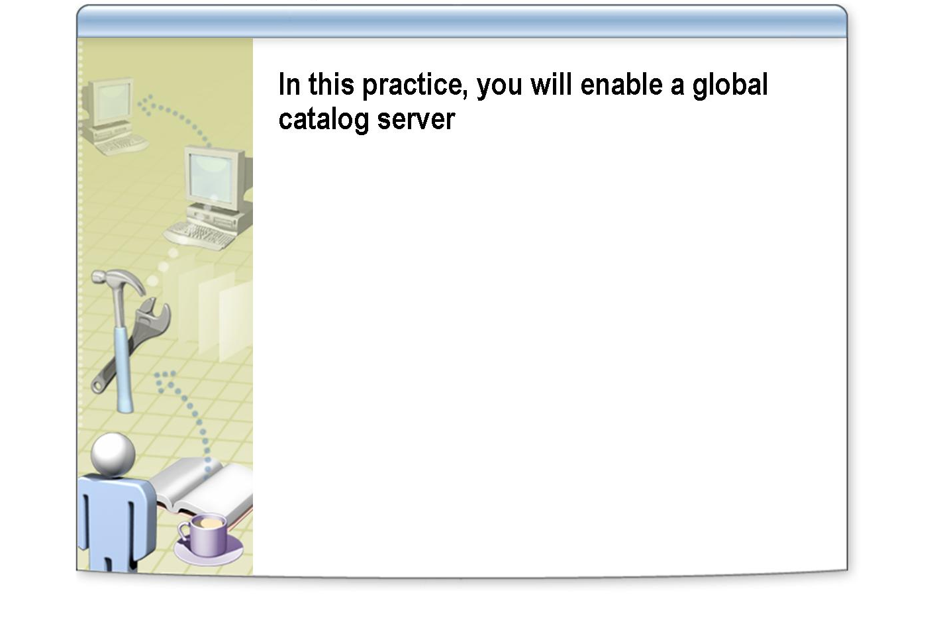
*****************************illegal for non-trainer use******************************
In this practice, you will enable a global catalog server.
Objective
Your organization has 4,000 users in a multidomain forest. There is one domain controller in a branch office that has 200 users who are part of a domain that has 2000 user accounts. You want to enable users to log on to the domain, even if the WAN link is unavailable.
Scenario
- Enable a global catalog server
Practice
    - Log on as Nwtradersx\ComputerNameUser (where ComputerName is the name of the computer you are working on) with a password of P@ssw0rd
    - Click Start, point to Administrative Tools, right-click Active Directory Sites and Services, and then click Run as.
    - In the Run As dialog box, click The following user, type YourDomain\Administrator as the user name with a password of P@ssw0rd and then click OK.
    - Use Active Directory Sites and Services to access NTDS properties for your domain controller.
    - Ensure that the Global Catalog check box is selected, and then click OK.
    - Close Active Directory Sites and Services.

Lesson: Determining the Placement of Domain Controllers in Active Directory

INCLUDEPICTURE "E:\\Documents and Settings\\Annie Chowdhry\\Application Data\\Microsoft\\Word\\PowerPnt\\2279B_08\\Slide_497.jpg" \* MERGEFORMATINET INCLUDEPICTURE "../Modules/PowerPnt/2279B_08/Slide_497.jpg" \* MERGEFORMATINET 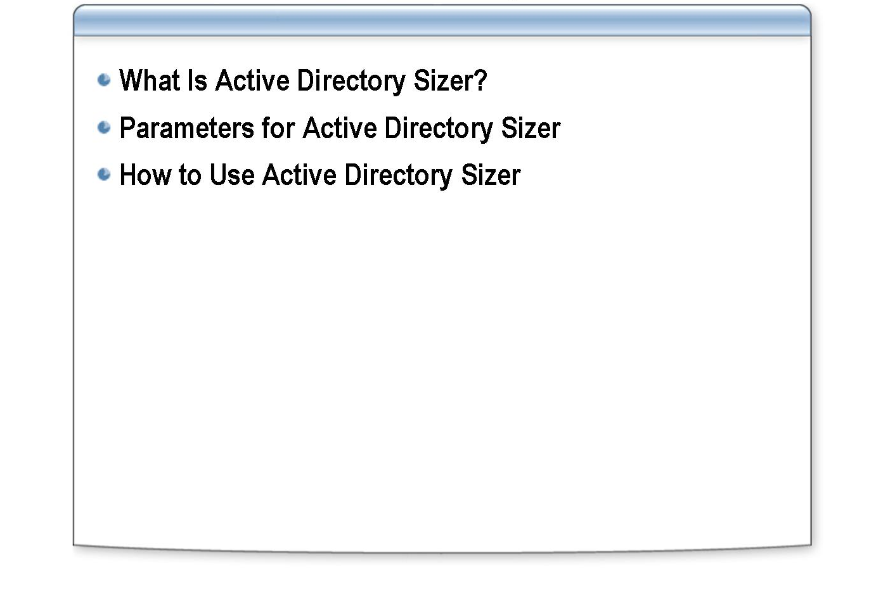
*****************************illegal for non-trainer use******************************
Before you place domain controllers in sites, you must determine the number of domain controllers that your organization needs and their hardware requirements. Active Directory Sizer is an executable file that helps you perform these two tasks, so that you can minimize cost and maintain an effective service level for your users.
Introduction
After completing this lesson, you will be able to:
Lesson objectives
- Explain the purpose of Active Directory Sizer.
- Describe the parameters of Active Directory Sizer.
- Determine the placement of domain controllers by using Active Directory Sizer.

What Is Active Directory Sizer?

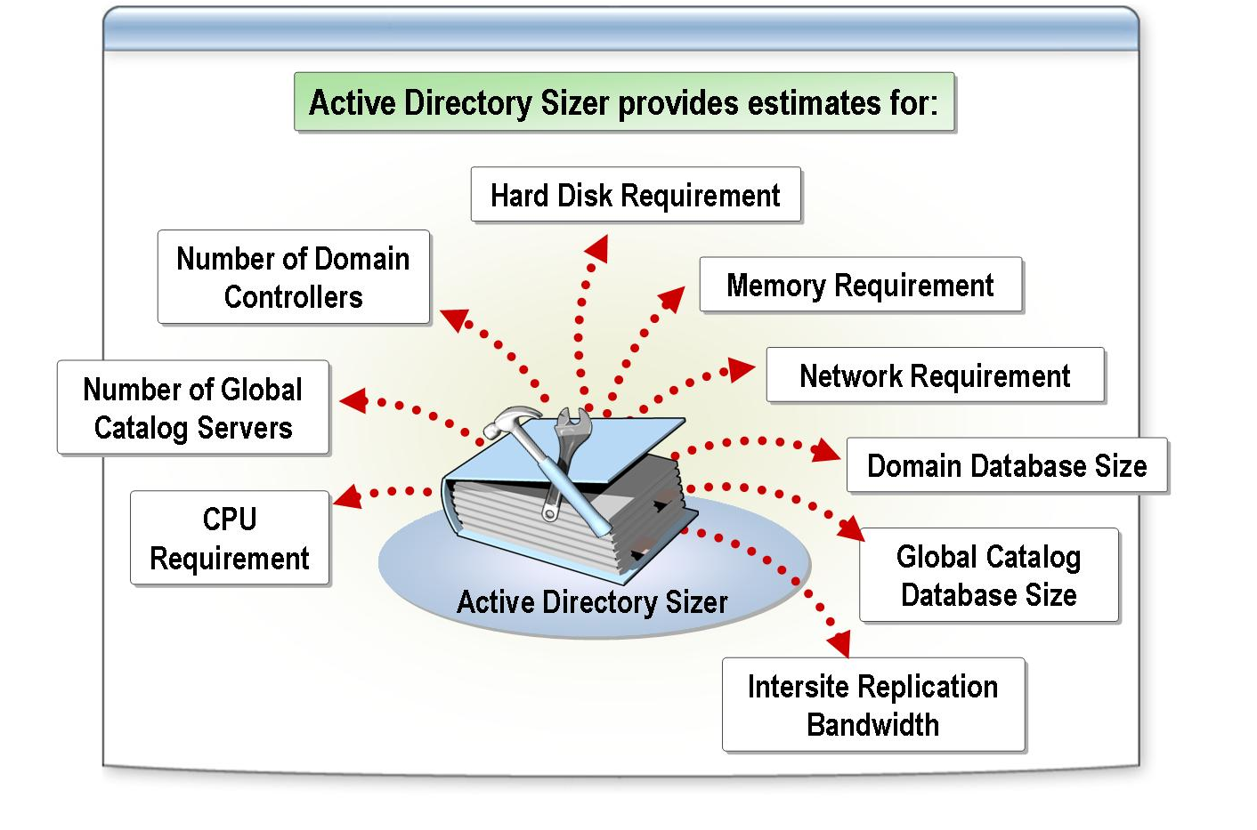
*****************************illegal for non-trainer use******************************
Active Directory Sizer (ADSizer.exe) helps you estimate the hardware that is required to deploy Active Directory based on the organization’s profile, domain information, and site topology.
Introduction
You use Active Directory Sizer to provide estimates of the number of:
What does Active Directory Sizer provide?
- Domain controllers per domain per site.
- Global catalog servers per domain per site.
- CPUs per computer, and the type of CPU.
- Disks that are required to store Active Directory data.

Active Directory Sizer also provides approximate estimates for the following requirements or parameters:
- Amount of memory
- Network requirement
- Domain database size
- Global catalog database size
- Intersite replication bandwidth

Parameters for Active Directory Sizer

INCLUDEPICTURE "E:\\Documents and Settings\\Annie Chowdhry\\Application Data\\Microsoft\\Word\\PowerPnt\\2279B_08\\Slide_502.jpg" \* MERGEFORMATINET INCLUDEPICTURE "../Modules/PowerPnt/2279B_08/Slide_502.jpg" \* MERGEFORMATINET 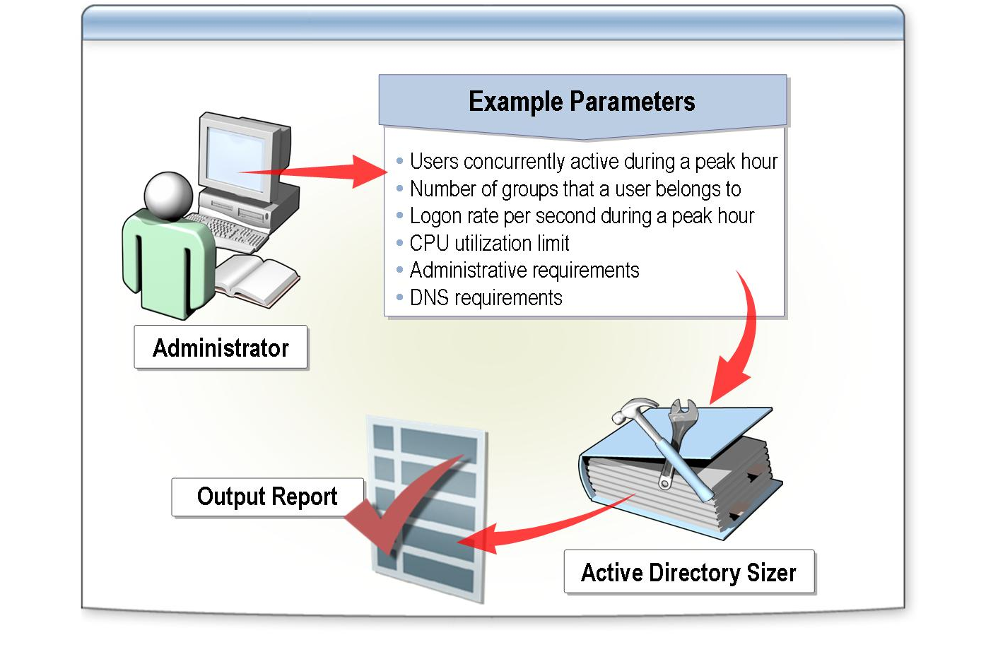
*****************************illegal for non-trainer use******************************
When you run Active Directory Sizer gathers the following information on each domain so you can accurately place the domain controllers:
Introduction
- Number of users
- Attributes per user
- Groups that a user belongs to
- Logon rate during peak hours
- Password expiration rate
- Number of computers
- CPU utilization limit
- Administration
- Information about the Domain Name System (DNS)

When you enter critical information in some of the parameters in Active Directory Sizer, consider these factors:
Considerations
- Percent of users who are concurrently active during a peak hour. If most users log on during a peak hour, specify a value of 100 percent. Typically, this parameter pertains to an Internet Service Provider (ISP), which may have a million users in a domain, but not all of them are active at the same time. Although it helps to know the total number of users to calculate the database size, Active Directory Sizer uses only the number of concurrent users to calculate the client logon traffic.
- Average number of groups that a user belongs to. This number can affect the time it takes a domain controller to process a logon request because user access depends on the access permissions for each group. During the logon process, the domain controller adds each group’s security identifier (SID) to the security token of the user. This parameter pertains to all types of groups—local, global, and universal.
- Average logon rate per second during a peak hour. If you do not know the rate, use the following method to estimate it:

      - Determine how many concurrent users in your organization are likely to log on to the system during a peak hour. For example, between 8 A.M. and 9 A.M.
      - Divide this number by 3,600 seconds for the average logon rate per second.
The estimate assumes that, for every interactive logon, Windows 2003 Server performs on average 15 network logons. If users log on to two or more computers, adjust the logon rate appropriately.
- Required average CPU utilization limit for each domain controller. This limit is only applicable for Active Directory. If you plan to use the domain controller to host services other than Active Directory, consider specifying a lower value to account for the average CPU utilization of those services.
Specifying a lower value allows the domain controller to accommodate a sudden increase in workload. However, if you lower this value too much you may cause Active Directory Sizer to predict more domain controllers than may be required to manage a typical workload.
- Administrative requirements. Typically, you perform certain directory operations such as adding, deleting, or modifying objects on a daily, weekly, or annual basis. Before you stipulate your administrative requirements, consider whether your domain has more than one administrator, or more than one user has permissions to add, delete, and modify objects in the domain, and include that data in your estimate.
If an application uses Active Directory, do not add that information here.
- DNS requirements. Specify values in these parameters only if you use an Active Directory integrated DNS.
  - Aging and scavenging. Aging is the process of identifying resource records that DNS created dynamically, and that the client computer that created the records has not updated in a timely manner. Records that are identified by this process are considered stale. Having many aging resource records can cause problems. For example, they take up space on the server, and DNS server performance can suffer because a server may use an aging resource record to answer a query. To solve these problems, the DNS server in Windows Server 2003 can scavenge aging records. Scavenging is the process of deleting stale resource records from the DNS server’s zone databases.
  - NoRefreshInterval. This value is the interval between the last time a record was refreshed and the earliest time that it can be refreshed again. Note that the server still accepts updates during this interval.

For more information about aging and scavenging, see the DNS MMC console help.
Note

How to Use Active Directory Sizer

INCLUDEPICTURE "E:\\Documents and Settings\\Annie Chowdhry\\Application Data\\Microsoft\\Word\\PowerPnt\\2279B_08\\Slide_515.jpg" \* MERGEFORMATINET INCLUDEPICTURE "../Modules/PowerPnt/2279B_08/Slide_515.jpg" \* MERGEFORMATINET 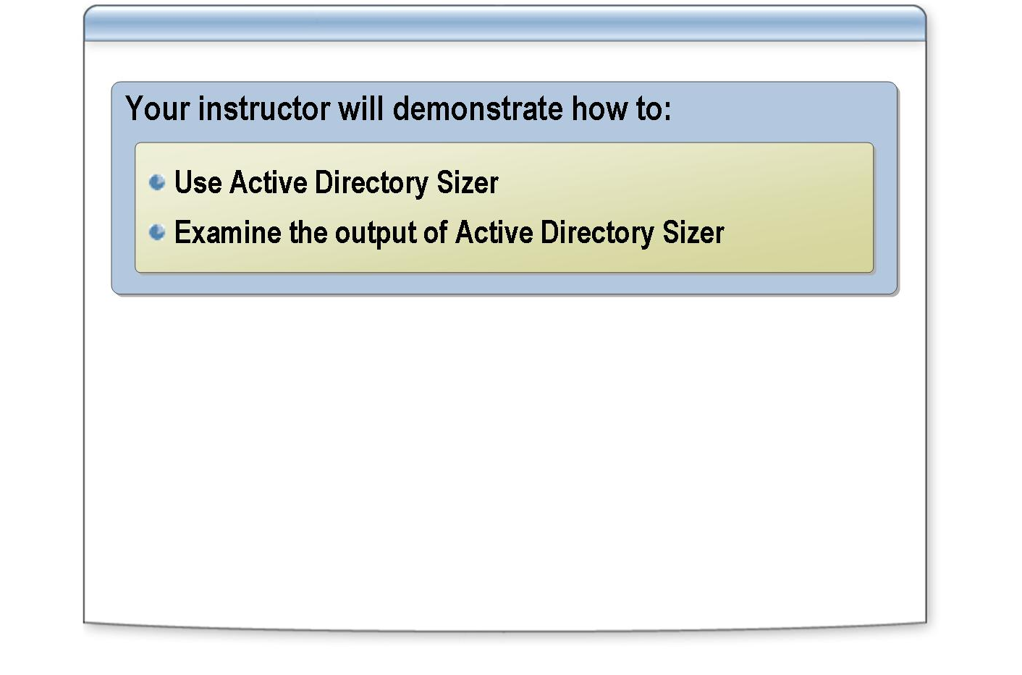
*****************************illegal for non-trainer use******************************
You use Active Directory Sizer to determine the placement of domain controllers.
Introduction
To use Active Directory Sizer, perform the following steps:
Procedure

Active Directory Sizer is not installed by default. You can download and install it from: http://download.microsoft.com/download/win2000platform/
ASsizer/1.0/NT5/EN-US/setup.exe.
Important
In this classroom, you can install Active Directory Sizer by running \\london\setup\adsizer\setup.exe and completing the setup wizard.

    - Click Start, point to Programs, click Active Directory Sizer, click File, and then click New.
    - In the Active Directory Wizard, specify a name for the domain, and then click Next.
    - On the User Accounts page, specify the total number of users and the number of users logged on during peak times, specify additional attributes, and then click Next.
    - On the next User Accounts page, specify the average number of groups that a user will belong to, specify the number of days for password expiration, specify a value for interactive, batch, and network in the average logon rate, and then click Next.
    - On the Computers and Other Objects page, specify the number of computers running Windows 2000, the number of other computers, and the number of other objects, and then click Next.
    - On the next Computers and Other Objects page, accept the default values for CPU utilization and preferred CPU type, and then click Next.
    - On the Administration page, specify values for the Interval, Add, Delete, and Modify boxes, and then click Next.
    - On the Exchange 2000 page, specify whether you plan to use Exchange, specify the average messages per day and the number of recipients, the number of Exchange servers and routing groups, and then click Next.

    - On the Services Using Active Directory page, select whether you plan to use an Active Directory-enabled DNS, specify the dial-in connections, and use the default values for Dynamic Host Configuration Protocol (DHCP) lease and NoRefreshInterval, and then click Next.
    - On the next Services Using Active Directory page, select the values for the services under Active Directory, click Next, and then click Finish.

After completing the wizard, if you have a multiple domain or multiple site environments, you can use the console tree to create additional domains or sites, and then distribute the user to the appropriate domains or sites.
When the procedure is completed, the Active Directory Sizer report displays the following information:
The Active Directory Sizer output
- The number of objects and the number of domain controllers that this domain requires. Always have at least two domain controllers per domain to provide fault tolerance.
- The size of Active Directory and the global catalog.
- The number of global catalog servers and bridgehead servers in each domain. The Active Directory Sizer makes the following assumptions:
  - A bridgehead server is a global catalog server.
  - One bridgehead server per site even if the site has multiple domains.
- The intersite replication traffic. Clicking a site shows the total volume of inbound and outbound replication traffic for that site. All intersite replication is Remote procedure call (RPC)-based. Active Directory Sizer accounts for compression when it calculates the amount of replication traffic.

The Active Directory Sizer makes hardware recommendations based on information that key vendors include with their current products. You can install a domain controller on a different hardware setup. Active Directory Sizer uses an algorithm that is based on scaling up rather than scaling out. Therefore, by using fewer computers that provide good hardware support for your domain workload, you can reduce replication latency in the system.
Note
Because the algorithm is based on scaling up, its recommendations may not meet the fault tolerance requirements for a domain or a site.

Practice: Determining the Placement of Domain Controllers in Active Directory

INCLUDEPICTURE "E:\\Documents and Settings\\Annie Chowdhry\\Application Data\\Microsoft\\Word\\PowerPnt\\2279B_08\\Slide_499.jpg" \* MERGEFORMATINET INCLUDEPICTURE "../Modules/PowerPnt/2279B_08/Slide_499.jpg" \* MERGEFORMATINET 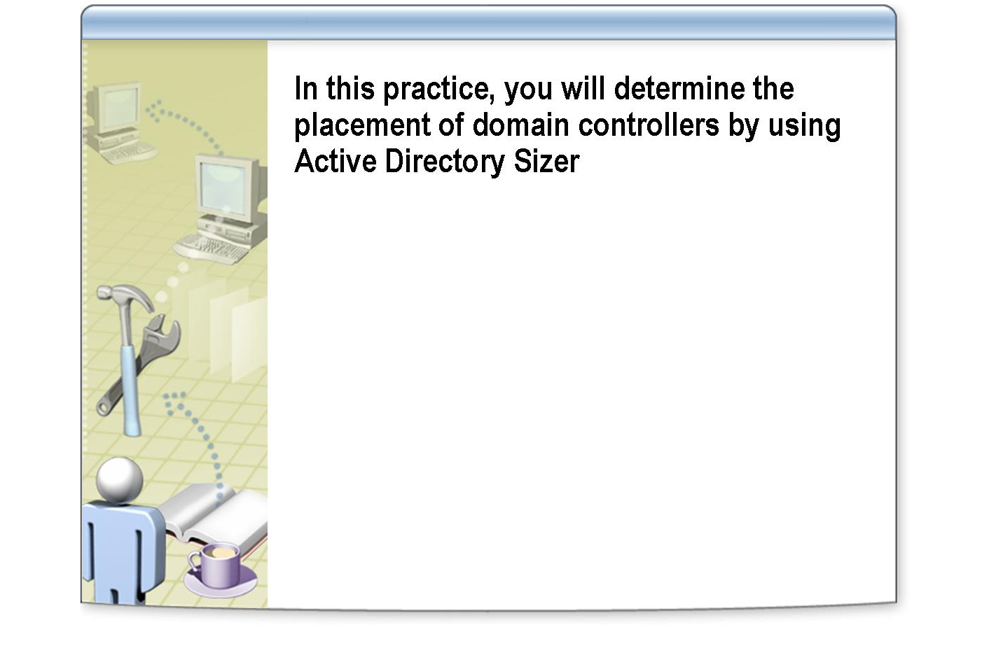
*****************************illegal for non-trainer use******************************
In this practice, you will determine the placement of domain controllers by using Active Directory Sizer.
Objectives
Woodgrove Bank is a small local bank with five branches in Chicago. The bank has 375 employees: 300 employees at its corporate headquarters and 15 employees at each branch. Woodgrove Bank has chosen to use:
Scenario
- A single-domain strategy.
- A domain name of corp.woodgrove.msft.
- A single-site strategy, with no servers at the branch offices.

Use the Active Directory Sizer to help you develop a placement plan for domain controllers for Woodgrove Bank.
- Determine server placement
Practice
    - Log on as Nwtradersx\ComputerNameUser with a password of P@ssw0rd
    - Click Start, point to All Programs, point to Active Directory Sizer, and then click Active Directory Sizer.
    - In the Active Directory Sizer dialog box, click File, and then click New.
    - When prompted, type the domain name, and then click Next.
    - On the User Accounts page, type the number of users, and then click Finish.
In the console tree, under Domain Configuration, the domain corp.woodgrove.msft appears and under Site Configuration, a default site named Default-First-Site appears. In the details pane, view the number of servers that Active Directory Sizer recommends that you place in the site.
    - Close Active Directory Sizer.

Lesson: Planning the Placement of Domain Controllers

INCLUDEPICTURE "E:\\Documents and Settings\\Annie Chowdhry\\Application Data\\Microsoft\\Word\\PowerPnt\\2279B_08\\Slide_474.jpg" \* MERGEFORMATINET INCLUDEPICTURE "../Modules/PowerPnt/2279B_08/Slide_474.jpg" \* MERGEFORMATINET 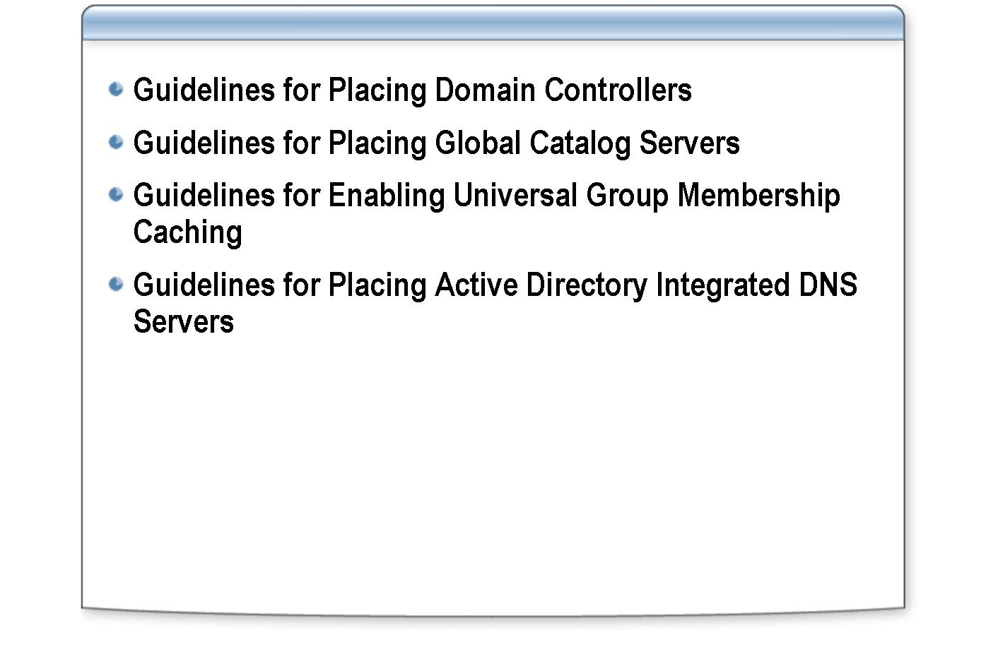
*****************************illegal for non-trainer use******************************
Planning the placement of domain controllers helps you determine your organization’s hardware requirements and prevents you from underestimating hardware requirements. It also ensures that you do not overload domain controllers running Windows Server 2003.
Introduction
Before you plan the placement of domain controllers, you must design and deploy an Active Directory site topology. For Windows Server 2003, the DNS service has been carefully integrated into the design and implementation of Active Directory. Therefore, when you deploy Active Directory and Windows Server 2003 together, you also must plan for the placement of Active Directory integrated DNS servers.
After completing this lesson, you will be able to:
Lesson objectives
- Explain guidelines for placing domain controllers.
- Explain guidelines for placing global catalog servers.
- Explain guidelines for enabling universal group membership caching.
- Explain guidelines for placing Active Directory integrated DNS servers.

Guidelines for Placing Domain Controllers

INCLUDEPICTURE "../Modules/PowerPnt/2279B_08/Slide_506.jpg" \* MERGEFORMATINET 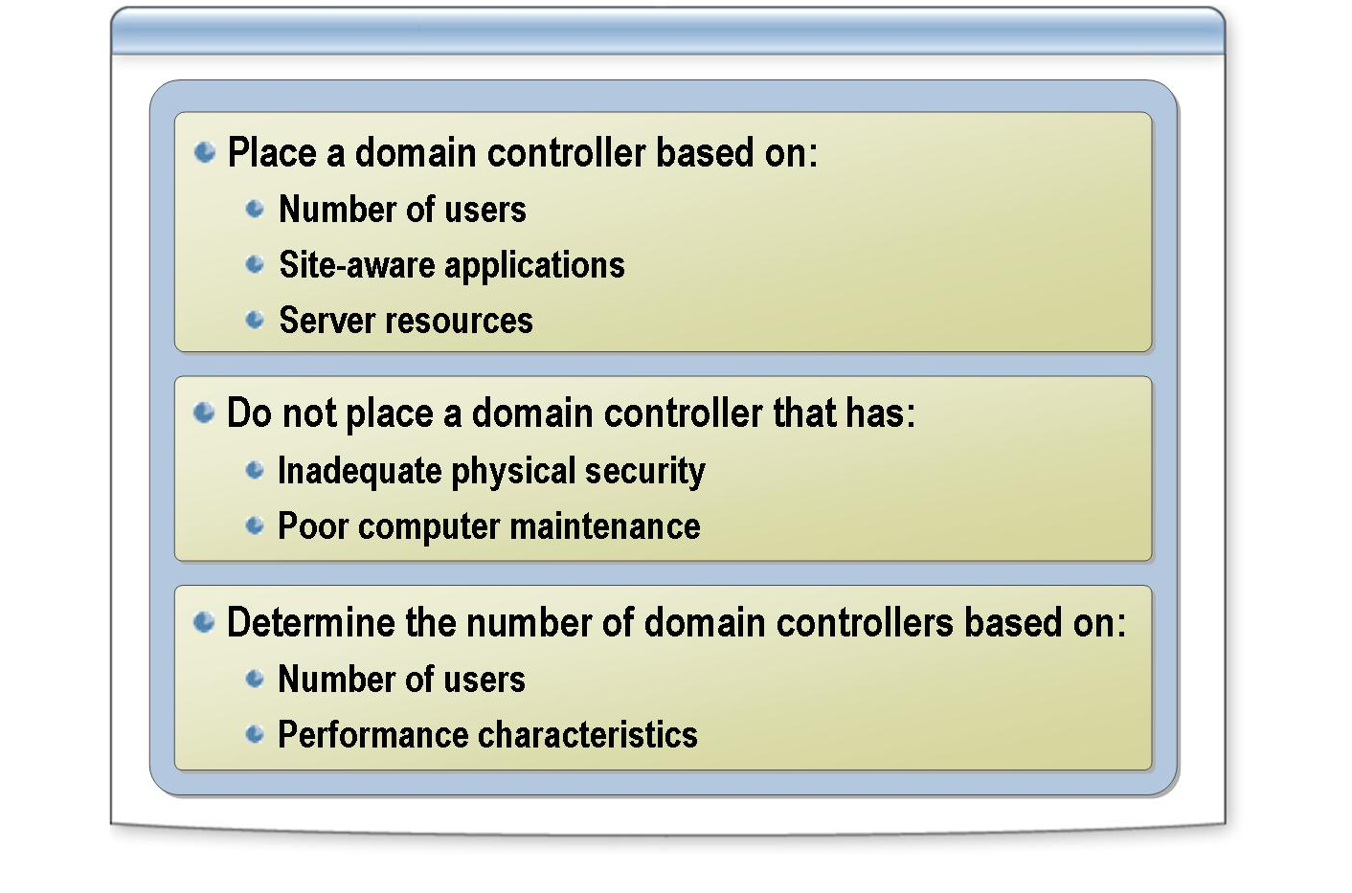
*****************************illegal for non-trainer use******************************
By following guidelines for placing domain controllers, you can minimize the response time to user inquiries and provide fault tolerance.
Introduction
Apply the following guidelines to place domain controllers:
Guidelines
- Place a domain controller in a site if:
  - There are many users in the site. When these users log on, they can contact a local domain controller for authentication, instead of contacting a remote domain controller over a WAN link.
  - Site-aware applications will be used in the site. These applications can then access a user account and other information from a local domain controller.
  - The site contains server resources that users can access when the WAN link is unavailable. If the WAN link is unavailable and no local domain controllers are available to process logon requests, users log on by using cached credentials They cannot access resources on any computers other than the one they are logged on to. If users must be able to access resources on other computers on the network, configure the domain controller as a global catalog server. Or, at a minimum, enable universal group membership caching for the site.
- Do not place a domain controller in a site that has inadequate physical security or poor corporate maintenance. If an intruder can physically access a server, it is much easier for him to bypass the security settings and access or modify critical corporate data. Without personnel to maintain local computers, a hardware or software failure on a domain controller may disrupt service for an unacceptable period of time.

- Determine the number of domain controllers based on the number of users and the required performance. Use Active Directory Sizer to determine specific CPU, memory, and network values. Also consider fault tolerance requirements. If Active Directory Sizer recommends only one domain controller for a site, but users must be able to log on and access local, server-based resources if a WAN link fails, consider placing a second domain controller in the site to meet your fault tolerance requirements.

Guidelines for Placing Global Catalog Servers

INCLUDEPICTURE "E:\\Documents and Settings\\Annie Chowdhry\\Application Data\\Microsoft\\Word\\PowerPnt\\2279B_08\\Slide_493.jpg" \* MERGEFORMATINET INCLUDEPICTURE "../Modules/PowerPnt/2279B_08/Slide_493.jpg" \* MERGEFORMATINET 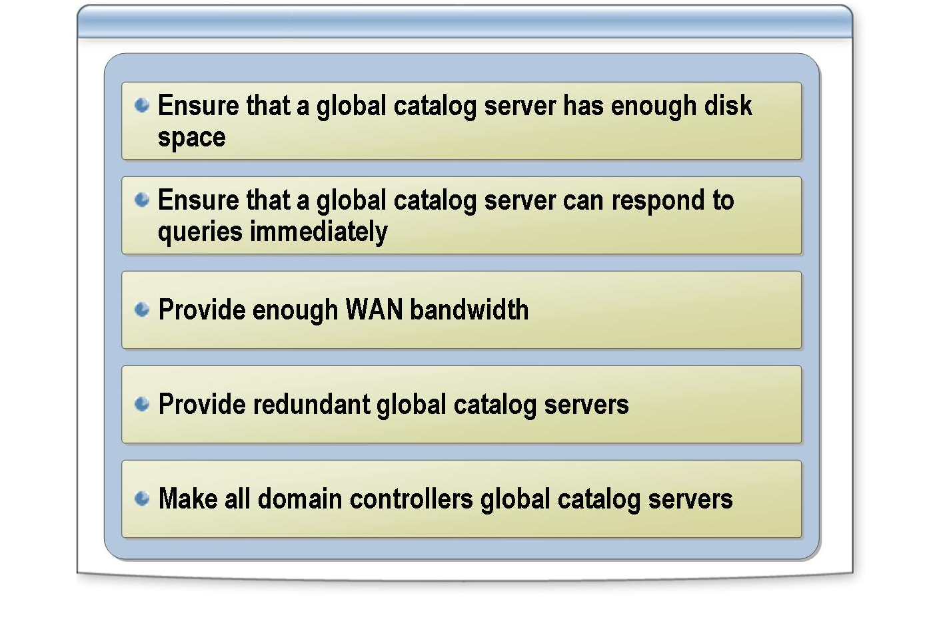
*****************************illegal for non-trainer use******************************
In an ideal environment, there is a global catalog server at each site that can process Active Directory query requests. However, too many global catalog servers may increase network traffic significantly because of the partial replication of all objects from all domains. Therefore, base your plan for placing global catalog servers on the capability of your network.
Introduction
Apply the following guidelines to place global catalog servers in sites:
Guidelines
- Ensure that a global catalog server has enough disk space. The disk must be able to hold partial replicas of all objects from all other domains in Active Directory.
- Ensure that a global catalog server can respond to client queries and authentication requests immediately. If there are many users in a site or if logon authentication is slow, consider placing more than one global catalog server in the site.
- Provide enough WAN bandwidth. Bandwidth is required to support global catalog replication traffic.
- Provide redundant global catalog servers. If you have access to a second global catalog server on your network , it helps you protect against failure of a global catalog server. If the servers are remote, redundant global catalog servers will not protect your organization against WAN failures.

- Make all domain controllers global catalog servers if you have only one domain in a forest. Because there is only one domain, making each domain controller a global catalog server will not increase replication traffic. Also, it will allow each domain controller to resolve queries to the global catalog locally, instead of contacting a global catalog server over the network.

In a single-domain forest environment, domain controllers do not contact a global catalog server when authenticating users because all universal group information is guaranteed to be stored on the domain controller.
Note

For more information about global catalog and sites, see “Guidelines for Placing Global Catalog Servers” in Module 8 on the Appendices page on the Student Materials compact disc.
Note

Guidelines for Enabling Universal Group Membership Caching

INCLUDEPICTURE "E:\\Documents and Settings\\Annie Chowdhry\\Application Data\\Microsoft\\Word\\PowerPnt\\2279B_08\\Slide_505.jpg" \* MERGEFORMATINET INCLUDEPICTURE "../Modules/PowerPnt/2279B_08/Slide_505.jpg" \* MERGEFORMATINET 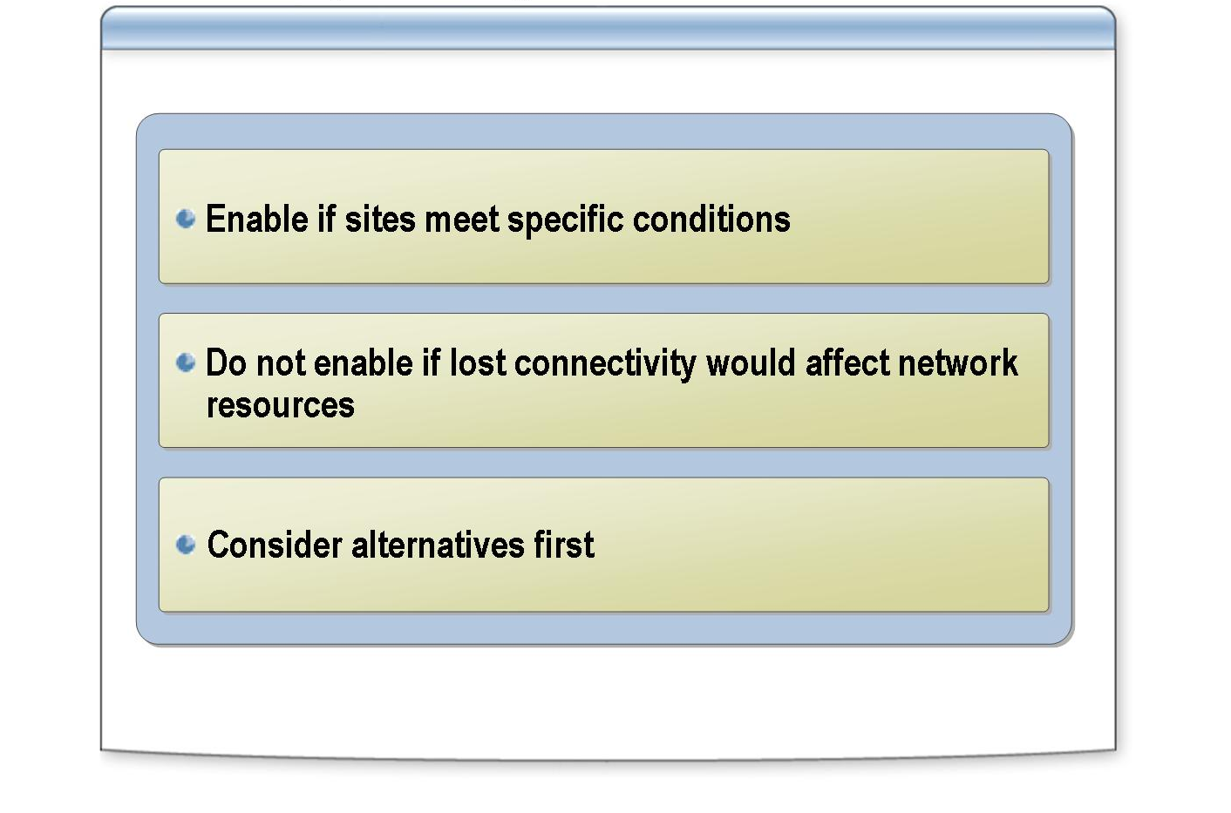
*****************************illegal for non-trainer use******************************
When you consider which sites to enable universal group membership caching for, develop a plan based on the ability of your network structure to manage replication and query traffic.
Introduction
Apply the following guidelines to determine whether to enable universal group membership caching for a site:
Guidelines
- Enable universal group membership caching in sites that meet these conditions:
  - Hardware or bandwidth limitations prevent you from placing global catalog servers in the site.
  - One or more local domain controllers are available.
  - Loss of connectivity to the global catalog server may be frequent or prolonged.
  - Network resource access cannot be interrupted.
The presence of these conditions does not mean that you must enable universal group membership caching in a site; rather, it indicates that using this feature may provide required redundancy.
- Do not enable universal group membership caching if lost connectivity would affect connectivity to other network resources. For example, do not enable universal group membership caching in small satellite offices with no local servers.
- Consider alternatives before you enable universal group membership caching. The following alternatives may indicate situations for which universal group membership caching is not appropriate.

  - Provide local global catalog servers. It helps protect each site against WAN failures. It may not be possible if hardware limitations or bandwidth restrictions obstruct the conversion of local domain controllers to global catalog servers.
  - Provide redundant WAN connections. Many local area networks (LANs) have redundant WAN connections in times of emergency. Typically, these connections have less available bandwidth than more permanent connections, but they are usually sufficient until network connectivity is restored.
  - Make all domain controllers global catalog servers. If there is one single domain in the forest, a global catalog server is not contacted during authentication. However, a global catalog server is still used for global catalog searches.

Guidelines for Placing Active Directory Integrated DNS Servers

INCLUDEPICTURE "E:\\Documents and Settings\\Annie Chowdhry\\Application Data\\Microsoft\\Word\\PowerPnt\\2279B_08\\Slide_487.jpg" \* MERGEFORMATINET INCLUDEPICTURE "../Modules/PowerPnt/2279B_08/Slide_487.jpg" \* MERGEFORMATINET 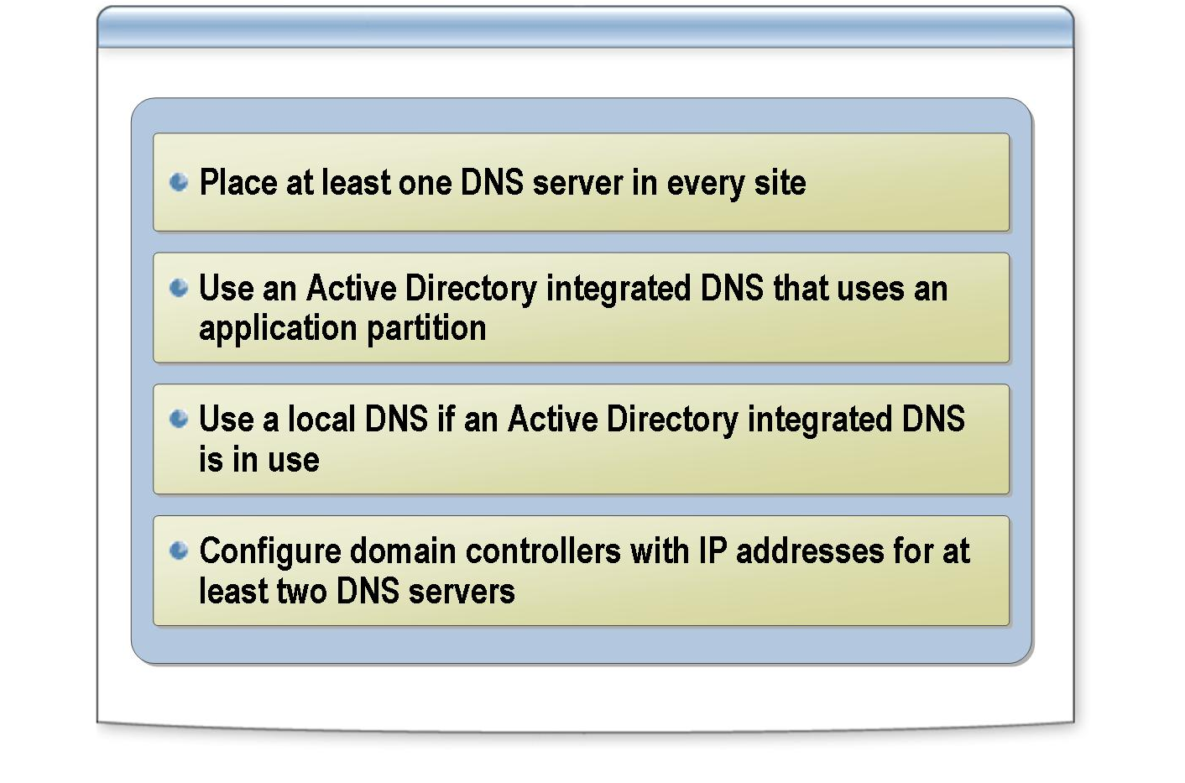
*****************************illegal for non-trainer use******************************
The availability of DNS directly affects the availability of Active Directory. Client computers use DNS to locate domain controllers, and domain controllers rely on DNS to locate other domain controllers. Even if DNS servers are deployed in the network, it may be necessary to adjust the number and placement of DNS servers to meet the requirements of the client computers and domain controllers.
Introduction
Apply the following guidelines to determine the placement of DNS servers in sites:
Guidelines
- Place at least one DNS server in every site. The DNS servers in the site must be authoritative for the locator records of the domain controllers in the site so that all DNS queries for domain controllers in the site are resolved by the local DNS server. Also, domain controllers periodically verify that the entries on the primary master server are correct for each locator record.
- Use an Active Directory integrated DNS that uses an application partition. Use this approach for all DNS servers in the domain. Run the DNS service on one or more domain controllers for each site where those domain controllers appear.
- Use a local DNS if an Active Directory integrated DNS is already in use. Logging on often takes longer when the DNS server is not located locally because the client computer must contact the DNS server over the WAN link to locate a domain controller to authenticate the user. If Active Directory integrated DNS is already in use on your network, and if you have a local domain controller, consider making the local domain controller a DNS server. This will enable client computers to resolve all DNS queries locally, instead of over the WAN.

- Configure domain controllers with IP addresses for at least two DNS servers. The two DNS servers are a preferred local server and an alternate server. The alternate server can be in the local site, or it can be remote if you only have a single DNS server in the local site.

For more information about DNS, see Module 2, “Implementing an Active Directory Forest and Domain Structure,” in Course 2279, Planning, Implementing, and Maintaining a Microsoft Windows Server 2003 Active Directory Infrastructure.
Note

Multimedia Practice: Placing Domain Controllers

INCLUDEPICTURE "E:\\Documents and Settings\\Annie Chowdhry\\Application Data\\Microsoft\\Word\\PowerPnt\\2279B_08\\Slide_461.jpg" \* MERGEFORMATINET INCLUDEPICTURE "../Modules/PowerPnt/2279B_08/Slide_461.jpg" \* MERGEFORMATINET 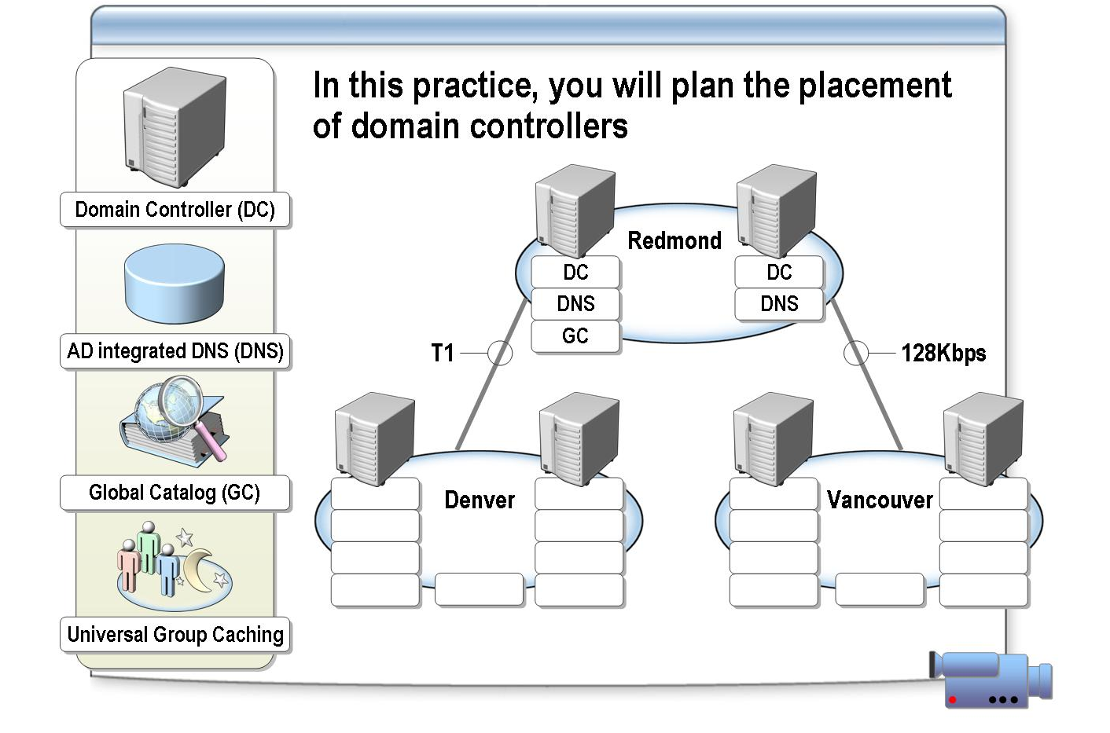
*****************************illegal for non-trainer use******************************
To view the Placing Domain Controllers multimedia practice, open the Web page on the Student Materials compact disc, click Multimedia, and then click the title of the presentation. Do not open this presentation unless the instructor tells you to.
File location
In this practice, you will plan the placement of Active Directory domain controllers in an organization.
Objective
The Placing Domain Controllers activity includes multiple choice and drag-and-drop exercises that enable you to test your knowledge. Click Multimedia, and then click Placing Domain Controllers. Read the instructions, and then begin the practice.
Instructions

Lab A: Implementing the Placement of Domain Controllers

INCLUDEPICTURE "E:\\Documents and Settings\\Annie Chowdhry\\Application Data\\Microsoft\\Word\\PowerPnt\\2279B_08\\Slide_412.jpg" \* MERGEFORMATINET INCLUDEPICTURE "../Modules/PowerPnt/2279B_08/Slide_412.jpg" \* MERGEFORMATINET 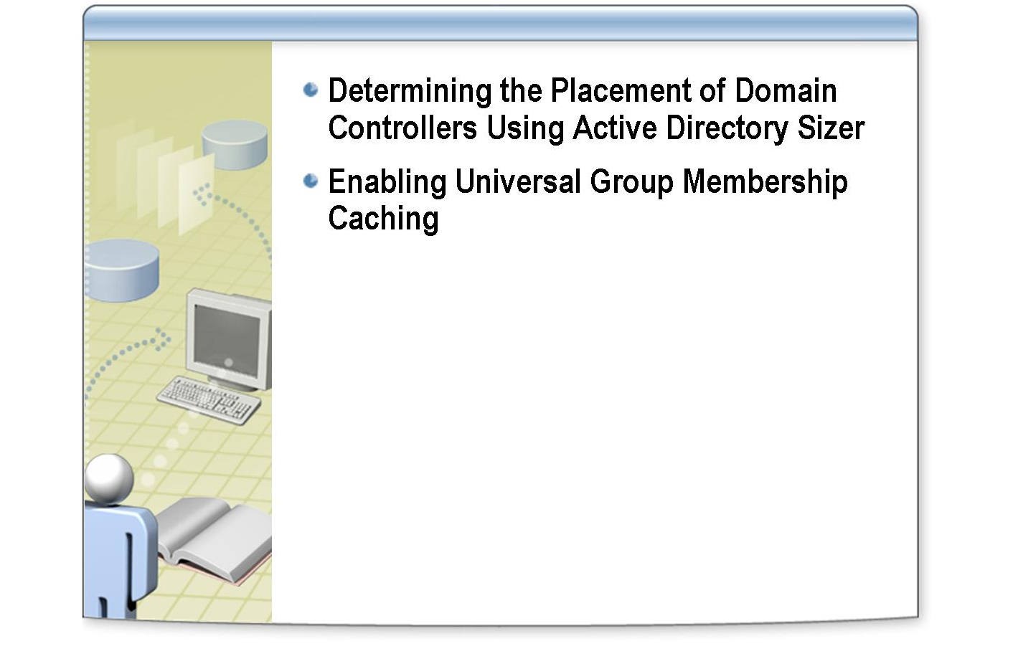
*****************************illegal for non-trainer use******************************
After completing this lab, you will be able to:
Objectives
- Determine the placement of domain controllers by using Active Directory Sizer.
- Enable universal group membership caching and specify which site domain controllers will contact to refresh the cache.

Before working on this lab, you must have:
Prerequisites
- Knowledge about how the logon process works.
- Knowledge about how sites, subnets, domain controllers, and global catalog servers affect the logon process.

Northwind Traders is an investment trading bank with 200 branches in Illinois, Indiana, and Ohio. Each regional center has its own IT staff that reports to the corporate IT staff, which is based at the bank’s headquarters in Chicago. Northwind Traders has chosen a single-domain strategy with the domain name of corp.nwtraders.msft. It will include three sites: Chicago, Indianapolis, and Columbus.
Scenario
Exercise 1
Determining the Placement of Domain Controllers Using Active Directory Sizer
Estimated time to complete this lab:
30 minutes

In this exercise, you will input information from the scenario into Active Directory Sizer to determine how many domain controllers, global catalog servers, and preferred bridgehead servers to place at each site for Northwind Traders.
Scenario
Northwind Traders has chosen:
- A single-domain strategy.
- A domain name of corp.nwtraders.msft.
- Three sites: Chicago, Indianapolis, and Columbus.

Operations at the Chicago site are critical for Northwind Traders. Users in this site must be able to log on and access network resources 24 hours per day, 7 days per week.
Northwind Traders officials have provided you with the following information about the number of users at each regional center.
Site | Number of branches | Total number of users
Chicago | 100 | 2,675
Indianapolis | 60 | 1,350
Columbus | 35 | 925
Total | 195 | 4,950

You have consulted the IT staff at the regional centers about their network and workstations. They provided the following information.

Item | Information
Percent of users concurrently active | 90
Average additional attributes | 25
Average groups per user | 30
Password expiration in days | 45
Average interactive logon rate peak per second | 5
Average batch logon rate peak per second | 0
Average network logon rate peak per second | 25
Windows 2000 computers | 4,000
Other computers | 1,000
Other objects to be published | 2,030
Desired average CPU utilization | 60%
Preferred domain controller CPU | Auto select
Number of processors in domain controllers | Auto select
Object additions per week | 20
Object deletions per week | 15
Object modifications per week | 500
Microsoft Exchange 2000 | Yes
Microsoft Exchange 2000 messages | 75
Microsoft Exchange 2000 recipients per message | 15
Exchange Servers | 2
Exchange routing groups | 1
Windows 2000 DNS | Yes
Dial-in connections | 100
DHCP lease expiration in days | 12
DNS NoRefreshInterval in days | 7
Other Active Directory services | None

Tasks | Specific instructions
- Open a new project in Active Directory Sizer, and then specify the required information. | - Log on as Nwtradersx\ComputerNameUser (where ComputerName is the name of the computer you are working on) with a password of P@ssw0rd  - In the Active Directory Sizer Wizard, when prompted, use the information provided in the scenario to complete the wizard.
- Create three sites in Active Directory Sizer. | - Create the following three sites:  - Chicago  - Indianapolis  - Columbus  .
- Distribute users to the sites that you just created. | - Use Active Directory Sizer.  - Move all users from Default-First-Site-Name site.
- View the site report in Active Directory Sizer. | - Note the recommended distribution of domain controllers, bridgehead servers, and global catalogs for each site.
How many domain controllers does Active Directory Sizer recommend for the Chicago site?

How many domain controllers will you recommend for the Chicago site?

Exercise 2
Enabling Universal Group Membership Caching

In this exercise, you will enable universal group membership caching for a site, and specify which site you will use to refresh the cache.
Scenario
One of the branch offices for Northwind Traders has grown so much that you have created a new site for it in Active Directory, and you have placed a domain controller that is not a global catalog server in the site. You must ensure that users can log on and access resources on local servers even if the WAN link fails. However, the WAN link to corporate headquarters is used heavily during the day to carry mainframe session traffic. You must minimize the amount of Active Directory replication traffic that is sent over this WAN link.

Tasks | Specific instructions
- Enable universal group membership caching for the LABComputerNameSite site, and configure it to be refreshed from the Default-First-Site-Name site. | - Log on as Nwtradersx\ComputerNameUser with a password of P@ssw0rd  - Use Run as to start Active Directory Sites and Services as Nwtradersx\Administrator with a password of P@ssw0rd

